Special Piping Item Gate Valves (Underground)

Contents
1 Principle Sketch 3
1.1 Sketch of Gate Valve with Bevel Gear and Spindle Extension 3
2 Technical Data and Administration Table XAS012 4
2.1 Special Requirements 4
3 Technical Data and Administration Table XAS013 5
3.1 Special Requirements 5

Principle Sketch

Sketch of Gate Valve with Bevel Gear and Spindle Extension
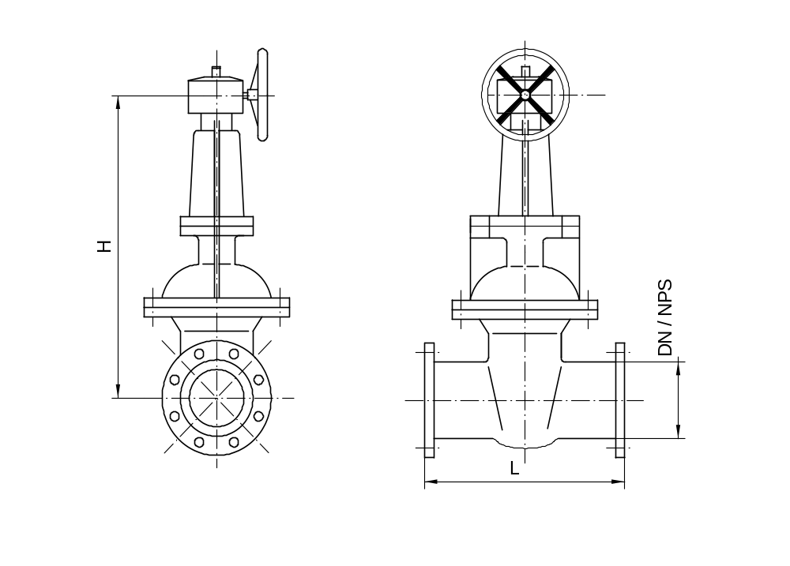

Design of valve extension:
- Spindle and valve remain unchanged
- Enlargement of valve with bevel gear by adapter
- Enlargement of valve with hand wheel by adapter

Technical Data and Administration Table XAS012
Special part number | XAS012
Ident | SX7499
PID Sheet | &AA P-FP 6501.01
Line number
Pipe class | BASR75
Fluid | Fire Water (UWFF)
Main Material | Carbon Steel High Temperature
NPS | 20
Pressure Class | CL150
Design Conditions | 10.34 barg / 66°C (150psig / 150°F)
Flange Connection | Flanged / ASME B16.5
Facing | Raised Faced (RF)
Body/Bonnet Material | ASME B16.34, Material Group 1.1
Trim No. | API 600 No.1 or 5
Body Bonnet Gasket | CrNi-Graphit
Material Bolts / Nuts | ASTM A193 GR. B7, ASTM A194 GR. 2H
L acc. sketch | Acc. ASME B16.10 → 457 mm (18 inch)
H acc. sketch | 2300 mm (90.55 inch)
Weight | 950 kg (2095 lbs)
Remarks | Position indicated and FM / UL approved

Scope:
- ASME B31.3

Design:
- Gate Valve with position indicator
- Analogous API 600
- Body Bonnet connection flanged
- With Bevel Gear
- Flexible or split wedge
- All parts contacting fluid are free of nonferrous metals
- FM / UL approval required

Quality assurance:
- Seat leakage rates acc. to API598

General:
All specified data are minimum requirements.
All parts not specified are to be designed acc. scope, service and fluids by manufacturers option.

Special Requirements
Acc. to LE-R-SP 1032 – Special Requirements for Valves

Technical Data and Administration Table XAS013
Special part number | XAS013
Ident | SX7500
PID Sheet | &AA P-FP 6505.01
Line number
Pipe class | BASR75
Fluid | Fire Water (UWFF)
Main Material | Carbon Steel High Temperature
NPS | 10
Pressure Class | CL150
Design Conditions | 10.34 barg / 66°C (150psig / 150°F)
Flange Connection | Flanged / ASME B16.5
Facing | Raised Faced (RF)
Body/Bonnet Material | ASME B16.34, Material Group 1.1
Trim No. | API 600 No.1 or 5
Body Bonnet Gasket | CrNi-Graphit
Material Bolts / Nuts | ASTM A193 GR. B7, ASTM A194 GR. 2H
L acc. sketch | Acc. ASME B16.10 → 330 mm (13 inch)
H acc. sketch | 2300 mm (90.55 inch)
Weight | 250 kg (550 lbs)
Remarks | Position indicated and FM / UL approved

Scope:
- ASME B31.3

Design:
- Gate Valve with position indicator
- Analogous API 600
- Body Bonnet connection flanged
- Flexible wedge
- All parts contacting fluid are free of nonferrous metals
- FM / UL approval required

Quality assurance:
- Seat leakage rates acc. to API 598

General:
All specified data are minimum requirements.
All parts not specified are to be designed acc. scope, service and fluids by manufacturers option.

Special Requirements
Acc. to LE-R-SP 1032 – Special Requirements for Valves

